
YQX Accessibility Plan – Progress Report
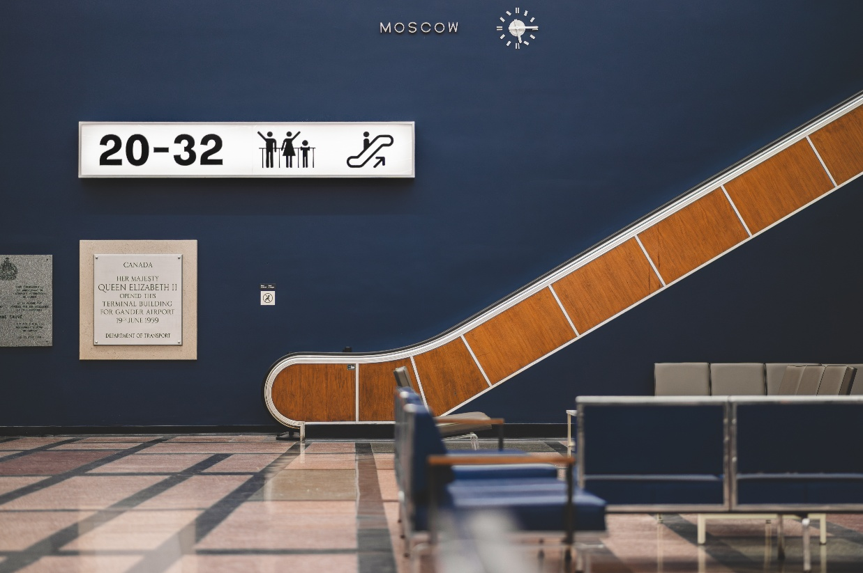
2024-2025

General
Who can I contact to give feedback or ask questions?
As a traveller, a member of the worker community, or an employee at Gander International Airport (YQX), if you would like to provide feedback about how YQX is implementing this Accessibility Plan or if you have encountered any barriers at YQX, please get in touch with us personally or anonymously using the email, phone number, or mailing address outlined above. Feedback can also be submitted through an online feedback form on our website or via direct messaging on social media (links provided below). Our feedback options give an acknowledgment of receipt and enable anonymous submission. The Manager of Security and Facilities is the designated person to receive feedback on behalf of YQX.
Contact Name: Garrett Watton, Manager of Security & Facilities
Phone: +1-709-256-6663
Email: info@ganderairport.com
Mailing Address:
1000 James Blvd.
Gander, NL, Canada
A1V 1W8
Website:
www.ganderairport.com
Facebook:
www.facebook.com/ganderinternationalairport
Twitter:
www.twitter.com/ganderairport

Alternate Formats
Upon request, an accessible alternate format (e.g., print, large print, Braille, audio format, or an electronic format compatible with adaptive technology) of this Accessibility Plan or the Feedback Process can be provided by contacting us at the mailing address, phone number, or email outlined below, or through any other links provided on this page.

Information and communication technologies (ICT)
During the consultation stage of our Accessibility Plan, several opportunities were identified to enhance information and communication technologies. Several of these priorities, along with their anticipated timelines, were captured in the original plan.
This Progress Report outlines the progress made on those initiatives to date. The organization will continue to evaluate and prioritize action items over the coming year.

Accessibility Goals | Target Date
Website and Social Media Platforms  - Explore options to integrate accessibility intelligence (AI) tools, so users can choose an option that works best for them, such as font and contrast adjustments and reading text to speech.  - Review and update website to meet Web Content Accessibility Guidelines (WCAG)  - Use alt text to provide text descriptions of images or videos posted online. | September 1, 2024  Ongoing with the website developer  September 1, 2024  Completed  Completed
Public Address (PA) and Sound Systems  - Review all audio systems to ensure announcements are clearly audible.  - Investigate the integration of visual displays into the PA system and all pre-recorded announcements.  - Investigate the integration of assistive listening technologies or hearing loop systems in all passenger and visitor areas. | December 1, 2024  Review completed. Changes have been made to the amplifier and PA inputs.  February 1, 2025  Review completed. The project scope has been identified and is in the planning stages.  February 1, 2025  Review complete. Will implement when the PA system is up for replacement
Self-serve kiosks  - Work with airline carriers and the Canada Border Services Agency (CBSA) to implement self-serve kiosks into their operations, that offer multilingual and universal signage to diversify the passenger experience | Ongoing  This has been added to the discussion list for future infrastructure upgrades.

Communication, other than ICT
During the consultation stage of our Accessibility Plan, several opportunities were identified to strengthen communication beyond ICT. Several of these priorities, along with their anticipated timelines, were captured in the original plan.
This Progress Report outlines the progress made on those initiatives to date. The organization will continue to evaluate and prioritize action items over the coming year.

Accessibility Goals | Target Date
Website  - Ensure all GIAA accessibility programs and services are presented on the website and discoverable through the search option. | December 1, 2024  Ongoing with the website developer
Signage  - Ensure all signage meets the accessibility standards, including font size, colour contrast, universal symbols and standard naming conventions  - Ensure all washroom and destination signage is capable of being read through tactile characters, raised symbols and or braille.  - Use inclusive terminology as a more universal language option. | Ongoing  Review Complete. Changes currently in progress  September 1, 2024  Completed  Ongoing  Review Complete. Changes currently in progress
Wayfinding  - Create a PDF Accessibility Map that clearly identifies the location of accessible features, facilities and services through the airport. | December 1, 2024  Review Complete. Changes currently in progress
Training  - Provide training to staff and airline partners to recognize and understand the nature of the person’s disability.  - Provide training to staff and airline partners so that they are familiar with the programs offered at the GIAA. | February 1, 2026  February 1, 2026

Procurement of goods, services and facilities
During the consultation stage of our Accessibility Plan, several opportunities were identified to enhance the procurement of goods, services, and facilities. Several of these priorities, along with their anticipated timelines, were captured in the original plan.
This Progress Report outlines the progress made on those initiatives to date. The organization will continue to evaluate and prioritize action items over the coming year.

Accessibility Goal | Target Date
Public Tendering and RFPs  - Ensure all public tendering and RFPs are viewed with an accessibility lens and  - Accessibility is integrated into the requirements. | Ongoing  Will be reviewed before each tender is issued.
Contracts  - Review current contracts to establish if accessibility initiatives can be integrated before contract renewal.  - Ensure managers understand how to evaluate accessibility requirements related to the procurement of goods and services. | October 1, 2024  Completed. It has been added as a requirement before the contract is renewed.  September 1, 2024  Completed
Vendor Accountability  - Ensure vendors are meeting their commitments to provide accessible services and to address accessible related requests and complaints in a timely manner. | Going forward  To be reviewed on an annual basis.

Design and delivery of programs and services
During the consultation stage of our Accessibility Plan, several opportunities were identified to enhance the design and delivery of programs and services. Several of these priorities, along with their anticipated timelines, were captured in the original plan.
This Progress Report outlines the progress made on those initiatives to date. The organization will continue to evaluate and prioritize action items over the coming year.

Accessibility Goal | Target Date
Lanyard Program  - Partner with Halifax International to implement Autism Aviators, a familiarization program to help neurodiverse people walk through every step in air travel in a mock check-in experience.  - Implement the Hidden Disabilities Sunflower Lanyard Program, which provides those with invisible disabilities the option to self-identify and allows airport workers to offer additional assistance. | December 1, 2026  December 1, 2024  Completed. Air Canada has implemented this program as part of their accessibility program.
Curbside Assistance  - Implement curbside assistance for passengers with disabilities through curbside signage, so passengers can call for service and be escorted to the check-in counter. | March 1, 2025  Currently in progress
Escort Passes  - Implement an escort program for passengers needing additional assistance so that support persons can follow through security to the departure gate. Passes can be issued by the airline as well as the Corp of Commissionaires. | October 15, 2026  Under review. Currently, these requests are being handled on a case-by-case basis. Transport Canada is currently implementing changes regarding escorts for passengers requiring assistance. This will be revisited once changes come into effect.

Transportation
During the consultation stage of our Accessibility Plan, several opportunities were identified to strengthen transportation. Several of these priorities, along with their anticipated timelines, were captured in the original plan.
This Progress Report outlines the progress made on those initiatives to date. The organization will continue to evaluate and prioritize action items over the coming year.
Accessibility Goal | Target Date
Parking  - Review long-term and employee parking lots to ensure they have the required ratio of Accessible parking stalls  - Ensure accessible parking signage is prominent. Each stall is to be equipped with paint markings and signage. | July 15, 2024  Review completed. New stalls will be created once space becomes available.  July 15, 2024  Currently in progress

Built Environment
During the consultation stage of our Accessibility Plan, several opportunities were identified to strengthen the built environment. Several of these priorities, along with their anticipated timelines, were captured in the original plan.
This Progress Report outlines the progress made on those initiatives to date. The organization will continue to evaluate and prioritize action items over the coming year.
Accessibility Goal | Target Date
Seating  - Retrofit existing seating in domestic and departures to offer accessible options like raised seats and armless end chairs with embossed accessibility symbols. | January 1, 2025  Currently in progress
Acoustic paneling  - Review installing acoustic panelling in open, noisier areas to reduce noise and vibration and provide a more calming environment. | Nov 1, 2026  Currently under review to implement this year.
Accessible Doors  - Retrofit existing accessible washrooms with occupancy notification systems.  - Install additional power door operators on the second-floor hallway. | Ongoing  Ongoing
Safety Features  - Assess air terminal building to ensure all applicable stairs, ramps, and curbs have slip-resistant strips and or colour contrast type markings.  - Tactile attention strips will be installed on the International Lounge stairs (top and bottom) and identified anywhere else in the review. | October 1, 2024  Review complete. Work plan is in place.  October 1, 2026
Evacuation Equipment  - Review current equipment installed in emergency exit stairways to ensure they are up to date and relevant to persons who cannot independently navigate stairs. | August 15, 2024  Reviewed by the OHS committee. Training and a live exercise to be held by airport staff and security in the coming months

Provisions of CTA accessibility-related regulations
Gander International is committed to complying with the requirements outlined in subsection 170(1) of the CTA. The Accessibility Plan, published in 2024, outlines the measures being implemented to meet these obligations. This Progress Report provides an update on provisions that remain in progress. The tables below identify areas where compliance has not yet been fully achieved and detail the actions underway to resolve them.
Accessibility Provisions | Target Date
Under the Personnel Training for the Assistance of Persons with Disabilities Regulations Act, GIAA has a responsibility to provide its Employees and Contractors with training appropriate to the requirements of their function in the following areas:  - Who interacts with the public  - Who provides physical assistance  GIAA must also ensure the timely completion of training and provide regular refresher training. | October 15, 2026  Review complete. Although some informal training has occurred, no formal training has been conducted by an outside organization or group. Training records have not been well-documented. There will be greater emphasis on this moving forward.

Feedback information
No feedback has been received since the end of the last reporting period. Any new feedback will be collected and included in the 2026 reporting period.
Consultations
No further formal consultations have been held since the end of the last reporting period. While changes to the accessibility plan during the 2025 reporting period were minimal, there have been significant improvements made throughout this year’s construction period. The GIAA will continue to engage airport partners, stakeholders, the traveling public, and persons with disabilities to ensure we remain on the right path toward a fully accessible and inclusive facility. Any new feedback will be collected and included in the 2026 reporting period.

